AIM: The aim is to develop a prototype incorporating both familiar and novel navigation elements and assess usability among diverse user groups using Proto.io.

PROCEDURE:
- Example 1: Tool Link: https://proto.io/
Step 1: Sign Up and Log In
1. Go to proto.io.
2. Sign up for a new account or log in if you already have one.
Step 2: Create a New Project
1. Click on "Create New Project."
2. Give your project a name (e.g., "Simple App Example").
3. Select the device type (e.g., Mobile - iPhone X).
4. Click "Create" to start the project.
Step 3: Design the Home Screen
1. Add a New Screen: ○ Click on the "+" button in the left panel to add a new screen. ○ Choose "Blank" and name it "Home."
2. Add Elements to the Home Screen: ○ Drag a "Header" widget from the "Widgets" panel to the top of the screen. ○ Double-click the header to edit the text and change it to "Home Screen." ○ Drag a "Button" widget onto the screen. Place it in the center. ○ Double-click the button to edit the text and change it to "Go to Profile."
3. Add Interaction: ○ Select the button and click on the "Interactions" tab on the right panel. ○ Click "+ Add Interaction." ○ Set the trigger to "Tap/Click." ○ Set the action to "Navigate to Screen" and choose "New Screen." ○ Create a new screen and name it "Profile."
Step 4: Design the Profile Screen
1. Add Elements to the Profile Screen: ○ On the newly created Profile screen, drag a "Header" widget to the top of the screen. ○ Double-click the header to edit the text and change it to "Profile Screen." ○ Drag an "Image" widget onto the screen. Place it below the header. ○ Double-click the image to upload a profile picture or any placeholder image. ○ Drag a "Text" widget onto the screen to add some profile information (e.g., "John Doe, Software Engineer").
2. Add Back Button: ○ Drag a "Button" widget onto the screen. ○ Double-click the button to edit the text and change it to "Back to Home."
3. Add Interaction: ○ Select the button and click on the "Interactions" tab on the right panel. ○ Click "+ Add Interaction." ○ Set the trigger to "Tap/Click."

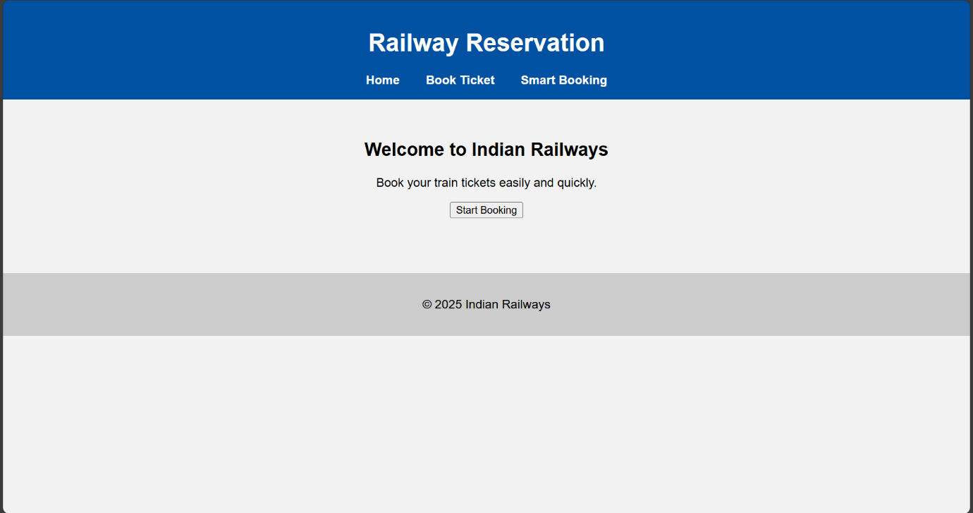

- Example 2:
- Step 1: Plan Your Prototype
- 1. Identify Your Elements: ○ Familiar: Common navigation elements such as a top menu bar, side panels, breadcrumb trails, and footer links. ○ Unfamiliar: Experiment with things like hidden menus, gesture-based navigation, or voice commands.
- 2. Sketch Out Your Concept: ○ Draft wireframes on paper, using tools like Figma or Sketch to visualize how both elements will coexist.
- Step 2: Start Your Project on Proto.io
- 1. Sign Up/Log In: ○ Go to Proto.io and either create an account or log in if you already have one.
- 2. Create New Project: ○ Click on the “Create a new project” button, select the type of project, and give it a name.
- 3. Choose a Template: ○ Select a template that suits your needs or start from scratch.
- Step 3: Design Your Screens
- 1. Familiar Navigation: ○ Drag and drop elements like menus, tabs, buttons that users are accustomed to.
- 2. Unfamiliar Navigation: ○ Add unique elements such as swipe gestures, hover interactions, or voice commands.
- 3. Link Screens: ○ Use Proto.io’s interaction design tools to set up transitions between screens.
- Step 4: Gather User Groups
- 1. Define User Groups: ○ Segment users into different categories such as age group, tech-savviness, or experience with similar products.
- 2. Recruit Participants: ○ Use platforms like UserTesting, surveys, or social media to find participants.
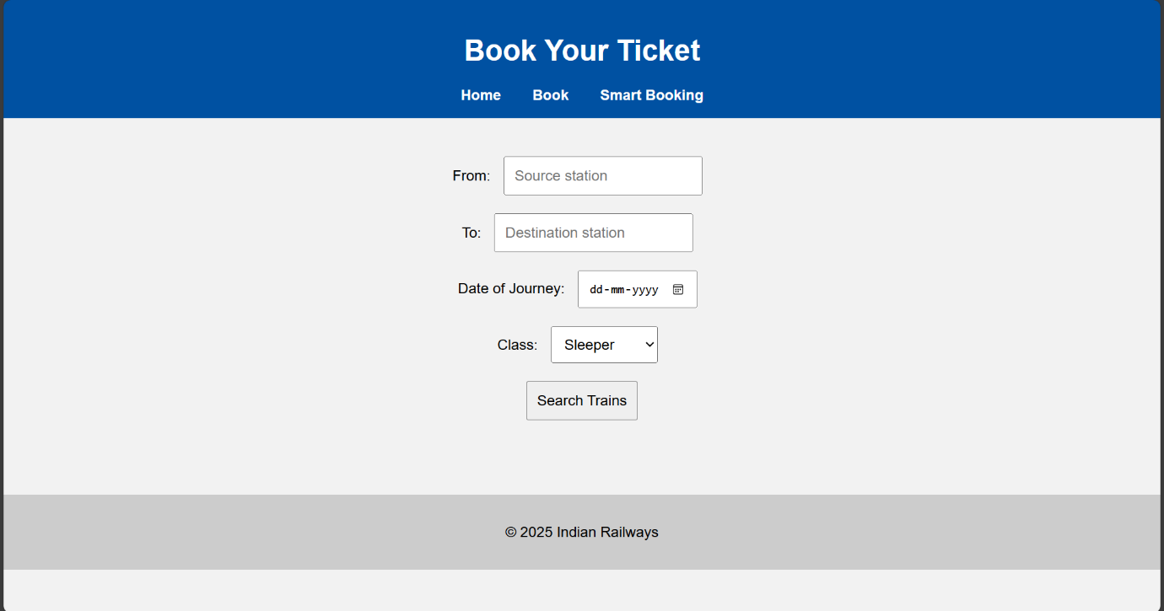
Step 5: Conduct Usability Testing

1. Deploy the Prototype:
○ Share the unique project link or invite users to test your prototype directly
through Proto.io.
2. Test Sessions:
○ Conduct usability tests with users from each group, giving them specific
tasks to accomplish.
3. Collect Feedback:
○ Use Proto.io’s feedback tools or conduct interviews to gather their thoughts
and experiences.
Step 6: Analyze and Evaluate

1. Data Analysis:
○ Look at how users interacted with each element. Use Proto.io’s analytics
tools to draw insights.
2. Compare Groups:
○ Compare how different user groups responded to familiar vs. unfamiliar
navigation.
3. Report Findings:
○ Summarize the results in a detailed report highlighting key insights, pain
points, and recommendations.

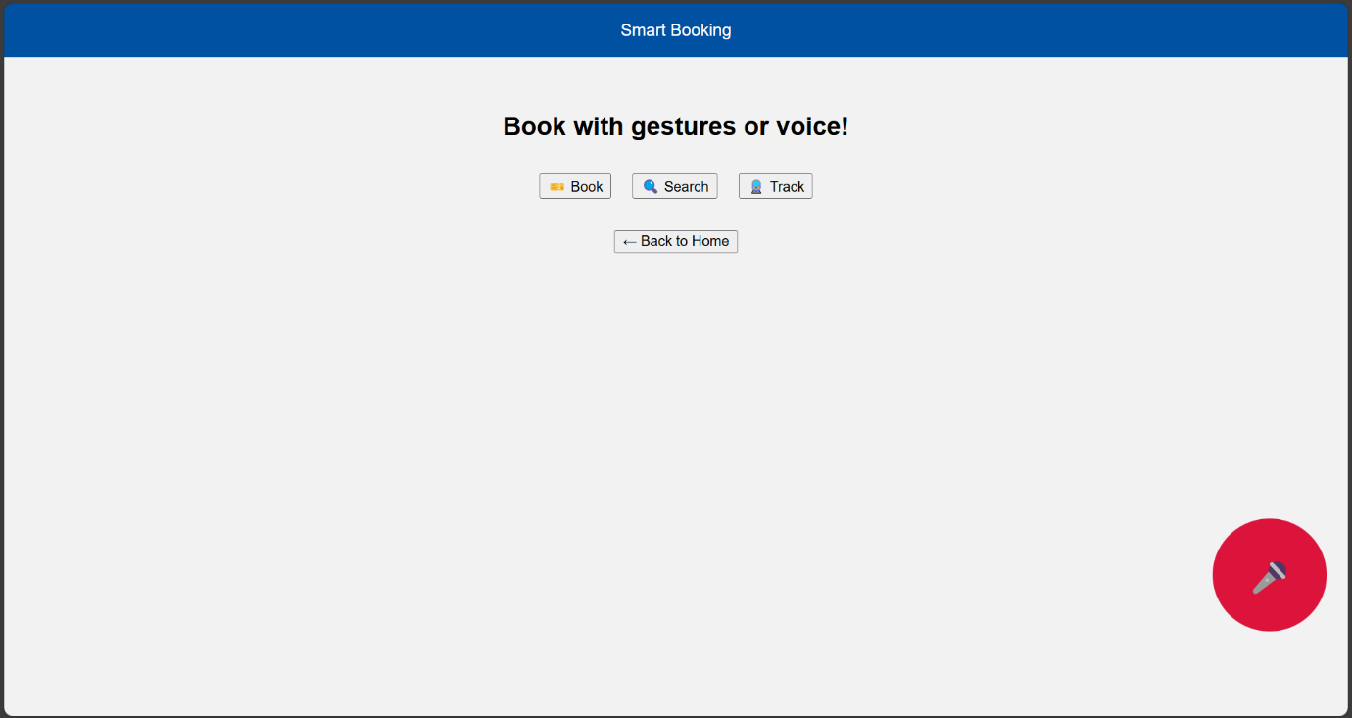

Railway Reservation UI/UX Prototype – Summary
- Built using: HTML, CSS, JavaScript in VS Code
- Pages:
  - index.html: Home with familiar nav (menu, button, footer)
  - booking.html: Classic form-based booking (familiar UX)
  - smart-booking.html: Circular menu, voice button, swipe gesture (unfamiliar UX)
- Navigation Types:
  - ✅ Familiar: Header, nav links, form
  - 🔄 Unfamiliar: Circular menu, voice icon, swipe left to go back
- Run using: Live Server in VS Code
- Goal: Compare user interaction with traditional vs modern navigation patterns

